**Assuming the local repository is called "millsph.github.io" and**

**1. The following steps is for uploading the web files to github account (to existing respository)**

**Go to directory in local PC to store the website code**

**cd C:\Users\lan\Documents\GitHub\millsph.github.io**

**from Startup run "Git shell" :**

* **git init (for the 1st setup –it is required; otherwise using**
* **git add \***
* **git commit -m "second commit"**

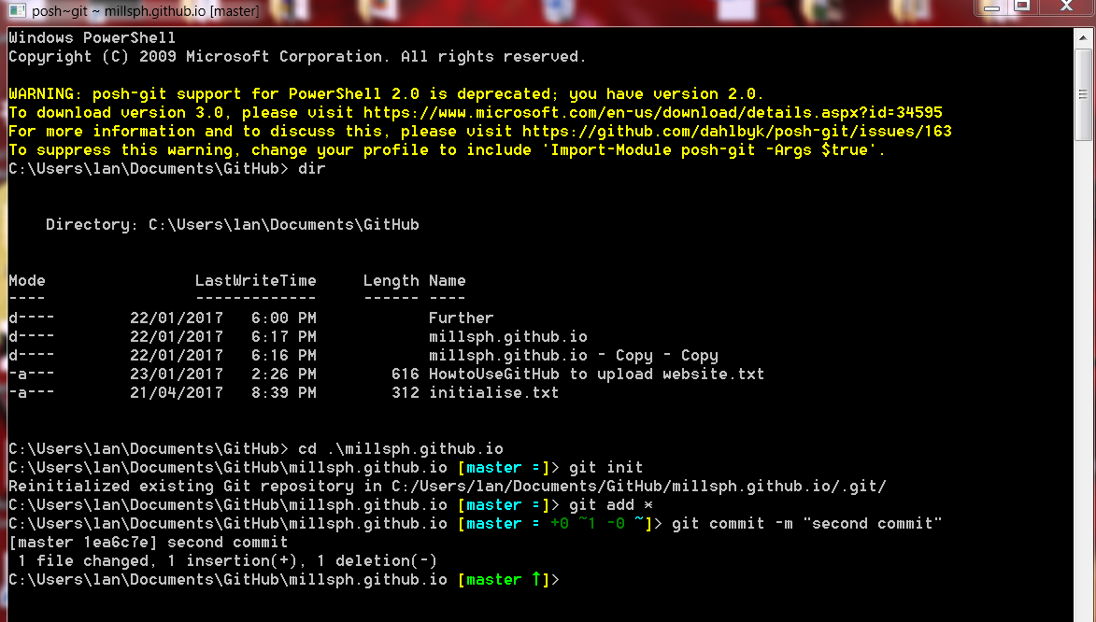

**Only Run this command at the 1st time – for initialise the new project:**

* **git remote add origin** <https://github.com/millsph/Further.git>

**Run git push to flush the buffer to complete the process.**

* **git push -u origin master**

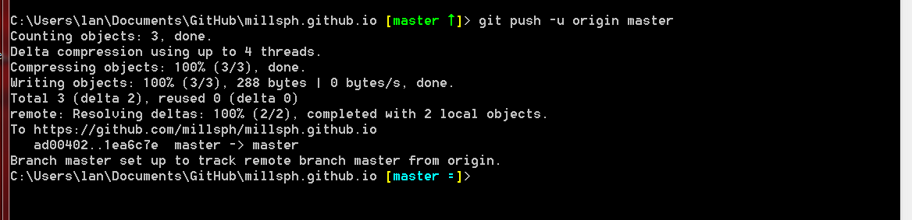

**The files are upload to existing website/repository ....**

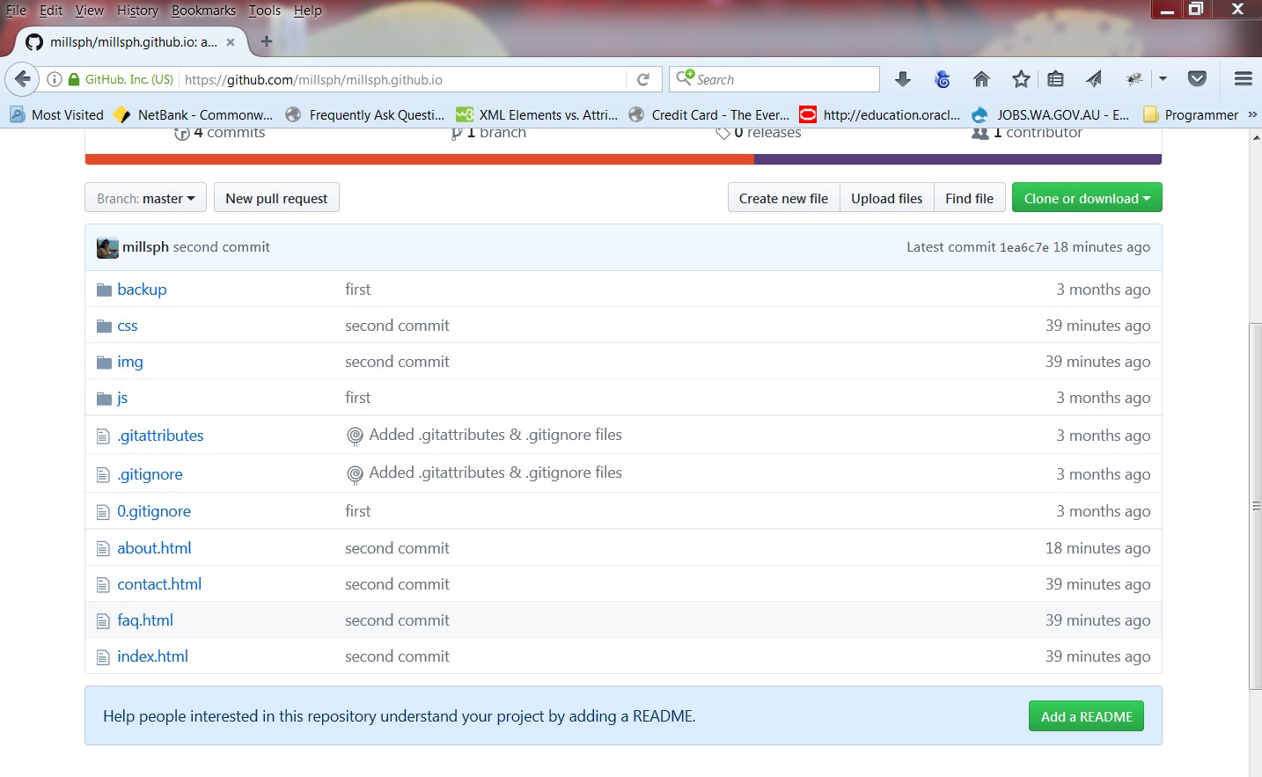

**Summary – to upload the files to existing repository in Github, run the 3 commands in GitShell:**

**git add \***

**git commit -m "new commit"**

**git push -u origin master**

**Check the website on Github :**

**For example :** <https://millsph.github.io/index.html>